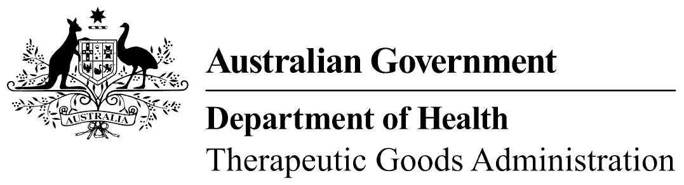
TGA use only

This form, when completed, will be classified as 'For official use only'.
For guidance on how your information will be treated by the TGA see: Treatment of information provided to the TGA at <https://www.tga.gov.au/treatment-information-provided-tga>.

Special Access Scheme – Category B
Important information  Email completed form to SAS@health.gov.au (preferred) or fax to 02 6232 8112.  The SAS Category B application form should be completed if guidance for use of an unapproved good will be met and the SAS Category A or SAS Category C pathways are not applicable. | Privacy information  For general privacy information, go to <https://www.tga.gov.au/privacy>.  The TGA is collecting personal information in this form in order to:  - Assess the application.  - Contact the health practitioner and discuss the application where necessary.  - The personal information of the health practitioner may be disclosed to State and Territory authorities with responsibility for therapeutic goods or health practitioner registration.
Do not provide the name of the patient. Only provide the patient’s initials and other information as requested on this form.
Please complete the form clearly and in full. Applications cannot be assessed if the form is incomplete or illegible. PLEASE PRINT IN BLOCK LETTERS.

Patient details (do not provide the patient’s name)
Patient initials  MM | Gender  Male Female Intersex/Indeterminate/Unspecified | DOB | MRN (if applicable)
Diagnosis(es) PTSD. |  |  | Previous SAS No. (if applicable)
Indication PTSD

Clinical justification for use of product(e.g. Include seriousness of condition, details of previous treatment including reasons why a therapeutic good currently listed on the ARTG cannot be used for the treatment of this patient in this circumstance)

This submission is an application to prescribe 3,4-methylenedioxymethamphetamine (MDMA) for the treatment of Post-Traumatic-Stress-Disorder (PTSD) in combination with psychotherapy for patient [initals].
[Initials] was diagnosed as suffering from Post Traumatic Stress Disorder (PTSD) on [date] following [history]. He has profound symptoms including [symptoms and functional/social losses]. He has a PCL-5 score of [number and interpretation]). Since [date], [initials] has been treated in accordance with within RANZCP and best practice guidelines in the following ways: He has received inpatient Prolonged Exposure Therapy, Outpatient therapy including trauma focussed therapy and EMDR. He’s had numerous admissions to hospital for PTSD. He’s had numerous medication trials, including high doses trials of [medications and other treatments]. Other medications include [others]. I have also previously sought other opinions and undertaken recommendations of opinions, also without sustained improvement. [initals] has had exhaustive treatments and did not improve symptoms significantly and has not had enduring remission of symptoms.
In my opinion, as his treating psychiatrist, we have exhausted clinically appropriate treatment options within RANZCP and best practice guidelines. The consequence of not having found a helpful treatment is a deterioration in [initial]’s mental state, resulting in increasing withdrawal, increased suicidality, isolation and social functioning loss, incapacity to work and adverse effects on marriage / family relationships as well as increasing health system costs. This in my opinion constitutes sufficient justification for consideration of treatment with a currently unapproved substance under the Special Access Scheme.
[patients current disposition]
A promising treatment avenue is MDMA-assisted psychotherapy, this modality has gained FDA Breakthrough Therapy Designation in 2017 as a result of research trials conducted in the USA by the Multidisciplinary Association for Psychedelic Studies (MAPS). I have studied integration therapy with MDMA. I have access to supervision for ongoing integration work for the use of MDMA along-side psychotherapy, specifically for PTSD. I am familiar with the protocols of MAPS in the use of MDMA for PTSD.

(continued over page)
Clinical justification for use of product(e.g. Include seriousness of condition, details of previous treatment including reasons why a therapeutic good currently listed on the ARTG cannot be used for the treatment of this patient in this circumstance)
(continued) There are a variety of treatment options for PTSD, of those currently available, trauma focused psychotherapy has been shown to be the most efficacious. Trauma focused psychotherapy modalities include; Trauma-Focused Cognitive-Behavioural Therapy (TFCBT); and Eye Movement Desensitization and Reprocessing (EMDR); Exposure Therapy (ET) and Somatic Experiencing among others. Despite this, of those entering treatment, only 44% of patients experience any clinical improvement in their PTSD symptoms from trauma focused psychotherapies. This figure is significantly less for remission. A significant impediment to the treatment of PTSD with psychotherapy is the high drop-out rate ranging from 30-50% across clinical trials, significantly higher than other mental health disorders.
Pharmacotherapy using antidepressant’s (such as selective serotonin reuptake inhibitors (SSRIs)) is often ineffective. Of those diagnosed with PTSD only between 20-30% respond to pharmacotherapy.
MDMA-assisted psychotherapy is emerging as a promising treatment for PTSD internationally, research is now progressing to Phase 3 internationally. The treatment involves in-clinic administration of medicinal MDMA alongside psychotherapy and has been found to lead to complete remission in 54.2% of patients in recent significant Phase 2 trials. These patients suffered from PTSD for an average of 18 years. Across these Phase 2 studies the dropout rate was only 7.6%, demonstrating high tolerability and patient adherence. Most adverse reactions were rated mild to moderate (jaw tension, anxiety, dizziness, sleepiness, lack of appetite, nausea) and there were no unexpected MDMA-related adverse events within these trials. MDMA has been shown to be non-addictive and non-toxic at doses used in clinical research trials. Doses well above these have been shown to be potentially neurotoxic in some studies of poly-drug users.
MDMA exerts its efficacy through anxiolytic, prosocial effects which work to negate the avoidance and hyperarousal characteristic of PTSD known to inhibit the therapeutic process. Neurologically, patients with PTSD experience increased activity in the amygdala and decreased pre-frontal functioning. In contrast, MDMA decreases activity in the amygdala and increases blood-flow to prefrontal regions. This neurobiological state creates a fertile ground for therapeutic work by decreasing fear and enhancing a patient’s capacity for communication and self-compassion. The advanced provision of MDMA-assisted therapy has been granted under the FDA’s ‘Expanded Access Scheme’ in the US and in Israel under the ‘Compassionate Access Scheme’. Australia would be following the international lead by making MDMA-assisted therapy available for at-risk patients.
The authorised provision of MDMA-assisted psychotherapy for patients with PTSD would include:
- Adherence to guidelines and protocols as specified by MAPS in their treatment protocols: Oral doses of 120mg-200mg of MDMA in three separate in-clinic sessions of psychotherapy across 6-8 hours for each patient.
- The provision of clinical support for this in the form of an appropriately trained psychiatrist/clinical psychologist to conduct the psychotherapy in the preparatory, acute and integration sessions.
- Creation of the recommended clinical setting, including adherence to protocols for safety and security and the management of risk.
- Pre- and post-treatment clinical and psychological assessment to enable an evidence-based approach to reporting on outcomes.
- Appropriate security measures for handling, safekeeping and administration of a schedule 9 substance.
- Established support and collaboration with MAPS by providing data for inclusion in their study. Data similarly being gathered and processed for inclusion in any future local study.

Evidence of Efficacy
Efficacy
There are 6 RCT studies investigating the use of MDMA in PTSD. Five of these studies have been subject to metanalysis by Bahji et al (2020). The metanalysis demonstrates efficacy across a variety of dose ranges. The ranges used were 50mg-75mg (weakest effect, Bouso et al [n=6] to 125mg-187.5mg (most robust effect, Mithoefer et al 2011 [n=12] and Oehen et al 2013 [n=8]). The other two studies pooled various doses between 30mg – 125mg with lesser (but still impressive) effects.

Here are two Forest Plots from Bahji et al (2020):

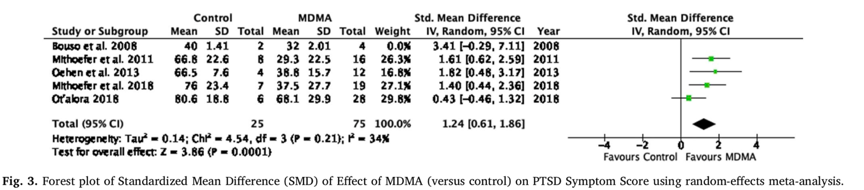
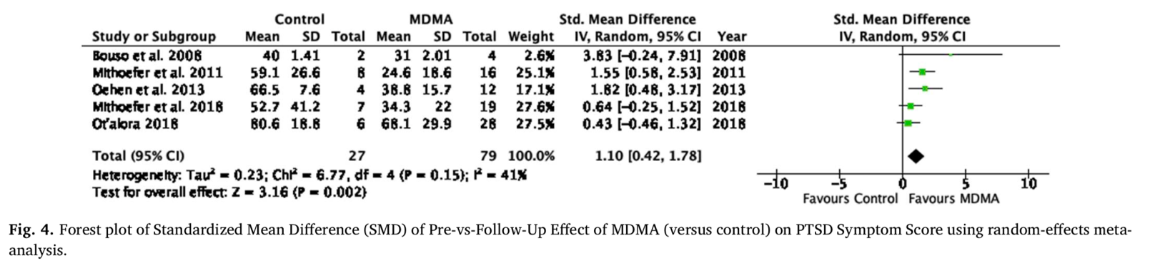

A notable more recent study by Mithoefer et al 2019 [n=72] used dosages of between 75-125mg with an optional supplemental dose equal to half the initial dose (total dose range is 75 – 187.5 mg) with striking findings. Their findings (graph below) are clinically very impressive and represent a marked diminution of symptoms to the point of remission for many cases.
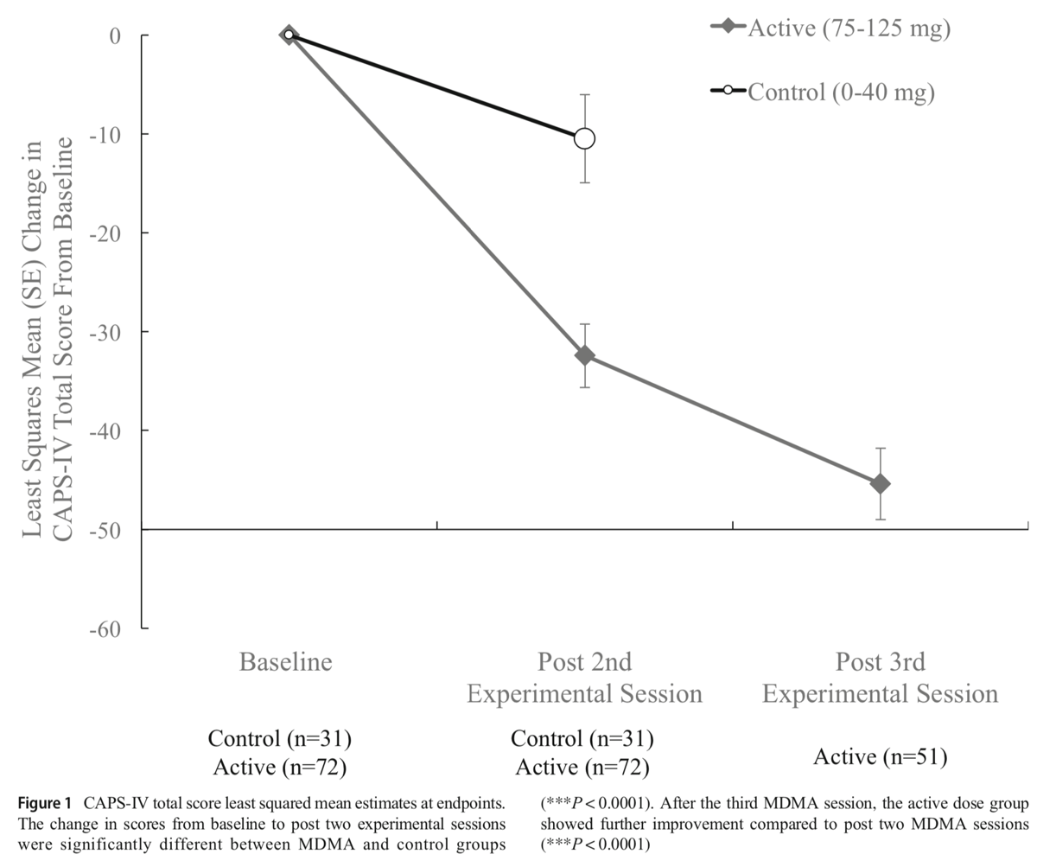

Safety
In studies to date with NDMA side effects are common, but minor and transient, typically resolving with supportive measures only. Occasionally hypnotics are used to deal with insomnia and NSAIDs for headache. Below is a table from Milhoefer et al 2019, the largest published study to date with a sample size of 72 at doses up to 187.5mg MDMA. There have been no reported serious adverse effects in the aforementioned studies. Milhoefer et al 2019 reviewed previous studies with regards to safety and tolerability and noted one exacerbation of ventricular extrasystoles and transient increase in suicidal ideation (but less than the control group).
I understand that recreational use of MDMA has been associated with serious negative outcome including death. This is usually in the result of fulminant hyperthermia in the context of hyperactivity in hot environments (dance parties) with severe dehydration/hyperthermia cascading to myopathy, DIC and renal failure (Henry et al 1992). Late presentation and polypharmacy are common concomitants. I would dose my patient without polypharmacy in a comfortable setting with regular physical observations within a hospital.
Mithoefer 2019 et al adverse effect findings:
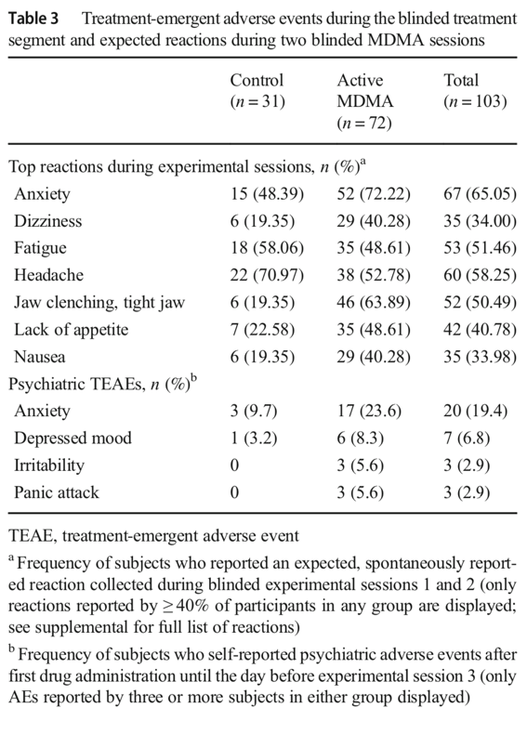

Rationale of proposed dosing:
Oral dosing has been studied and that is what I propose to use. I propose using an initial dose of 125mg followed by a supplemental dose of 62.5mg on three occasions. That seems to be the most effective dose from the literature. Phase 3 studies are underway with the following dosage protocol:
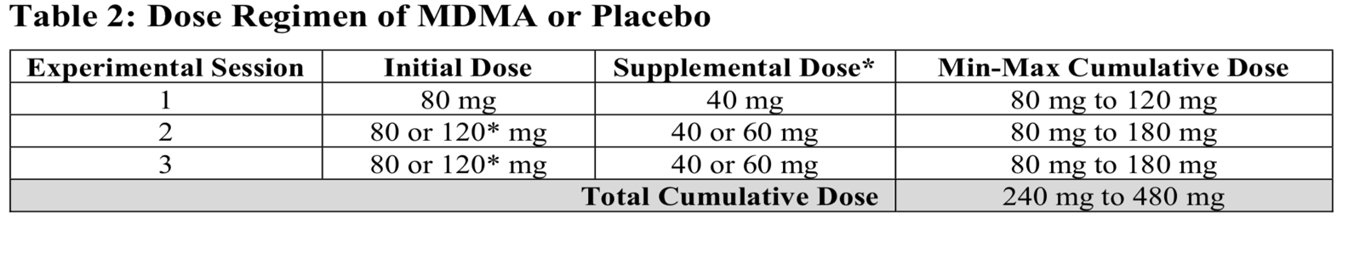
From: https://mapscontent.s3-us-west-1.amazonaws.com/research-archive/mdma/mapp1/MAPS-2018-02-26-MDMA-MAPP1-Public-Blinded-Protocol-A1V1-26FEB2018.pdf

Literature cited:
Bahji et al (2020) Efficacy of 3,4-methylenedioxymethamphetamine (MDMA)-assisted psychotherapy for posttraumatic stress disorder: A systematic review and meta-analysis. Progress in Neuropychopharmacology and Biological Psychiatry 96:1-15
Bouso et al (2008) MDMA-assisted psychotherapy using low doses in a small sample of women with chronic posttraumatic stress disorder. Journal of psychoactive drugs 40:225-234
Henry et al (1992). Toxicity and death from 3,4-methylenedioxymethamphetamine (“ecstasy”) Lancet 1992 340:384-87
Mithoefer et al (2011). The safety and efficacy of 3,4-methylenedioxymethamphetamine-assisted psychotherapy in subjects with chronic treatment-resistant posttraumatic stress disorder: the first randomised controlled pilot study. Journal of psychopharmacology. 25:439-452
Mithoefer et al (2018) 3,4-methylenedioxymethamphetamine (MDMA)-assisted psychotherapy for PTSD in military veterans, firefighters and police officers: a randomised, double blind, dose-response, phase 2 clinical trial. Lancet Psychiatry 5:486-197
Mithoefer et al (2018) MAPS Phase 3 protocol: A randomized, double blind, placebo controlled, multi-site phase 3 study of the efficacy and safety of manualised MDMA-assisted psychotherapy for the treatment of severe PTSD, https://mapscontent.s3-us-west-1.amazonaws.com/research-archive/mdma/mapp1/MAPS-2018-02-26-MDMA-MAPP1-Public-Blinded-Protocol-A1V1-26FEB2018.pdf
Mithoefer et al (2019) MDMA-assisted psychotherapy for the treatment of PTSD: study design and rationale for phase 3 trials based on pooled analysis of six phase 2 randomised controlled trials. Psychopharmacology 236:2735-2745
Oehen et al (2013) A randomised, controlled pilot study of MDMA (3,4-methylenedioxymethamphetamine)-assisted psychotherapy for the treatment of resistant, chronic Post-traumatic stress disorder (PTSD). Journal of Psychopharmacology 27:40-52

Product details (attach efficacy and safety data to support proposed use of the product and details of intended monitoring)
Medicine Biological  Trade Name (if known) Sponsor / Supplier Mind Medicine Australia (MMA)  Active ingredient(s)  3,4-methylenedioxymethamphetamine (MDMA)  Dosage form (e.g. tablet) Capsule Strength (e.g., 1 mg/ml) 125mg + 62.5mg  Route of administration (e.g., IV) Oral Dose & frequency (1 tds) 125mg - 187.5mg on three occasions.  Expected duration of treatment  3 doses in total over the course of ~20 weeks | Medical device  Trade name  Product description (including variant)  No of units to be supplied Sponsor / Supplier  Expected duration of treatment Intended date of use

Prescribing health practitioner details  First name Surname  AHPRA ID Health practitioner type Medical Practitioner  Email Speciality Psychiatrist  Fax Phone  Principal practice address | Submitter details (if different)  Business or practice name AHPRA ID  First name (as per AHPRA registration) Surname  Health practitioner type Fax  Email Phone  Preferred Contact: Prescribing health practitioner Submitter Preferred contact method: Email Fax Phone

Please note that the giving of false or misleading information is an offence under the Criminal Code Act 1995 and that penalties may be imposed.
Submitter’s signature | Date
Please send this form to the TGA only

Variant means a medical device the design of which has been varied to accommodate different patient anatomical requirements (for example, relating to the shape, size, length, diameter or gauge of the device)

